

School of Computer Science, UPES, Dehradun.

Lab 7

DevSecOps Lab

B.TECH. - V Semester

**Submitted to:**

Dr. Hitesh Kumar Sharma

**Submitted by:**

Name: Ishika Mehrotra

Batch: Devops B1

Sap Id: 500124411

Roll No.: R2142230281

**Objective:** To install the Maven plugin in Jenkins for smooth integration and automation of Maven-based build processes within the Jenkins environment

Step 1: Install the Maven plugin

* 1. Click on the Manage Jenkins option as shown in the screenshot below:

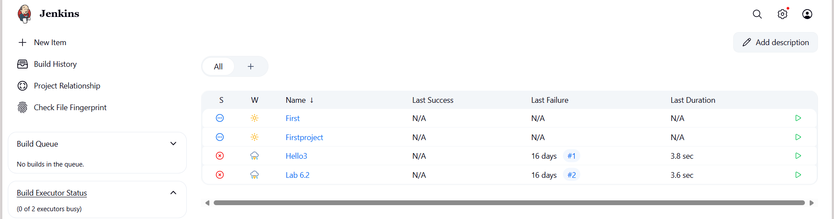

* 1. Click on the Plugins option as shown in the screenshot below:

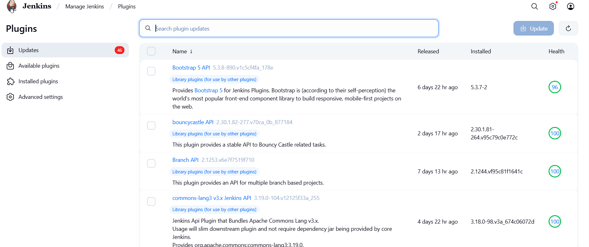

* 1. Click on Installed plugins to verify whether the Maven Integration plugin has been installed

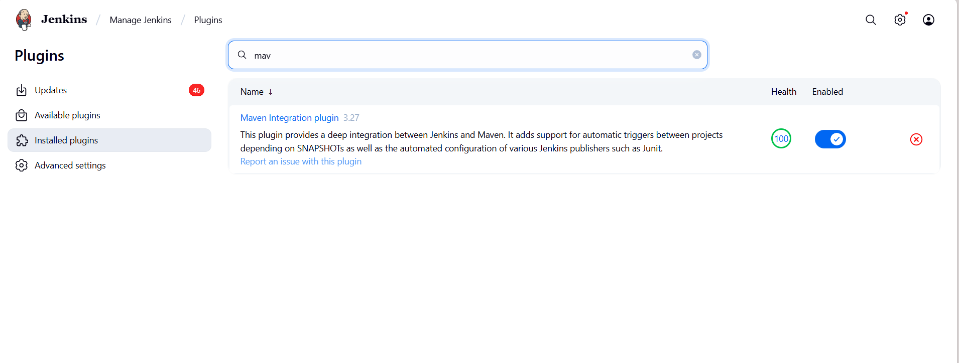

* 1. Use the following command to check the Maven version:

mvn -version

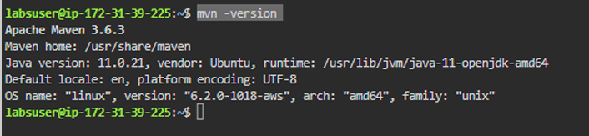

Step 2: Set up Global Tool Configuration 2.1 Go to the Jenkins Dashboard, click on Manage Jenkins, and then select Tools from the list of options

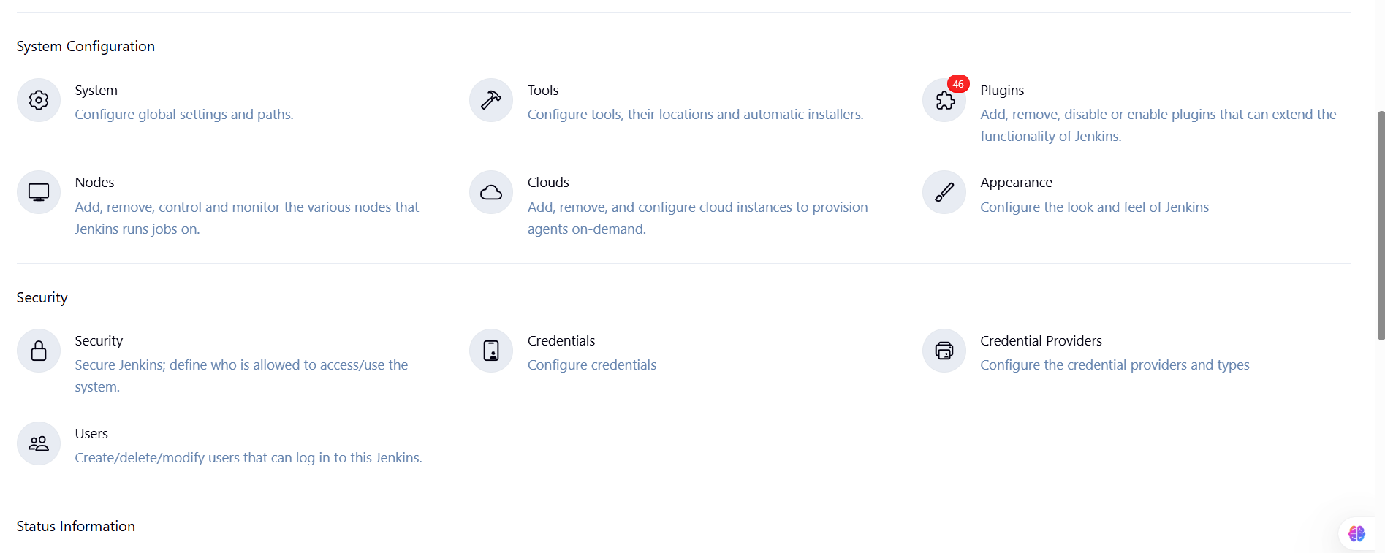

2.2 To configure Maven, click on the Maven installations button in the Maven section and enter a Name and MAVEN_HOME path

